photographer
Flashing A2 phones with A2Uploader
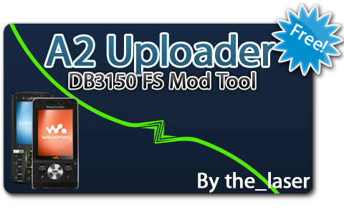
Flashing phones is not risky as long as you follow this tutorial. Still, I ,photographer, nor the se-nse.net staff or members will take responsibility in case you kill your phone by not following this tutorial. You do this at your own risk.
This tutorial was written by SE-NSE.net moderator Photographer and belongs to se-nse. Therefor this tutorial is NOT to be published on any other website. Linking to this tutorial is always alowed of course.
Is my phone A2?
These are all A2 phones as of 01-03-2010:
C Series: C510, C702, C901, C902, C903, C905
G Series: G502, G705
K Series: K630, K660, K850
T Series: T700, T707, T715
V Series: V640
W Series: W508, W595, W705, W715, W760, W890, W902, W910, W980, W995
Z Series: Z750, Z770, Z780
New SE phones: Jalou, Naite
My phone is not in this list!
Your phone is not compatible with A2 uploader, because it runs on a different platform. Try XS++ for older phones, such as W580, W610, W660, etc. Aino and Yari are incompatible with A2uploader.
Why would I want to flash my phone?
- Debrand (Remove Vodafone, Orange, etc crap)
- Upgrade to increase performance
- "Reset" everything you modded
What do I need?
- A2 uploader release 4 with limited CID53 and DB3200 support.
Disable your AV software before downloading. the_laser uses themidia encryption to prevent people stealing the sources and loaders of his A2uploader. AV software recognises this as virus/trojan horse but this is a false alarm. This software is completely safe.
If you can't download from rapidshare, use this mirror.
The latest version of A2 uploader can be found in this http://translate.goo...to&tl=en]thread[/url].
- A2 firmware for your phone.
Get them From my esnips
From Gani's esnips
From 4shared
From topse.ru
From SE Users
From iprotebe.cz
All of these sites are free but some require registration.
Which firmware do I need?
The latest firmware always has the highest number/character combination. e.g. R3EA037 is newer than R3DA031.
If you want an unbranded phone you have to choose a generic firmware, this will be stated in the name. For example W910 R1FA035 MAIN GENERIC SH RED52.
Always choose the right FS with your main firmware, these are the languages that are included in the different FS versions:
Regions and languages for A2 phones:
ADRIATIC en - sq - bg - hr - fr - de - el - it - ro - ru
AMERICA en - pb - cf - nl - fr - xl - es
APAC-ANZ en - nl - fr - de - ms - id - tl - th - vi - zs
BALTIC en - et - lv - lt - ru
C-ASIA en - ar - az - fa - kk - ru - tr - uk
CENTRAL-EUROPE en - bs - hr - de - cs - hu - pl - sr - sk - sl
CHINA en - zs
FRANCE en - fr
HONG-KONG en - zh
HUTCH-WORLD en - da - de - it - sv
ISRAEL en - ar - az - fa - fr - tl - he - hi - ru
JAMAICA en - pb - nl - fr - es
NORDIC en - sq - ar - hr - da - fi - is - no - sv - tr
ORANGE-CH-SI en - fr - it - de
ORANGE-SIGN en - eu - ca - nl - fr - gl - de - pl - ro - sk - es
RUSSIA en - ru
S-ASIA-LEVAN en - ar - az - bn - fa - fr - tl - he - hi - ru
S-CENTR-AFR en - ar - nl - fa - fr - ha - de - ig - st - yo - zu - pt
S-E-EUROPE en - sq - bg - hr - el - hu - mk - ro - ru - sr
TELEFONICA en - eu - ca - fr - gl - pt - es
TAIWAN en - zt
T-MOB-INT en - hr - cs - nl - de - hu - mk - pl - sk - tr
VFE-LIVE-A en - eu - ca - nl - fr - gl - de - it - pt - es
VFE-LIVE-B en - bg - hr - cs - de - el - hu - sl - ro
WESTERN-EUROPE en - eu - ca - nl - fr - gl - de - pt - es - tr
Your FS file will be called W910_R1FA035_FS_WESTERN-EUROPE_SH_RED52 if you want Dutch language files installed in your phone. If you want any other language, just search the FS version where your language is included. If you want Russian included, you download W910_R1FA035_FS_RUSSIA_SH_RED52. Don't forget to download the right firmware for YOUR phone. Flashing wrong firmware can be dangerous.
Let’s start!
(Be sure to have the USB drivers installed, run GG setup that comes with the A2uploader archive)
Before we start your battery has to have enough power left, 80% or more. Flashing with a low battery percentage can kill your phone.
Main screen:
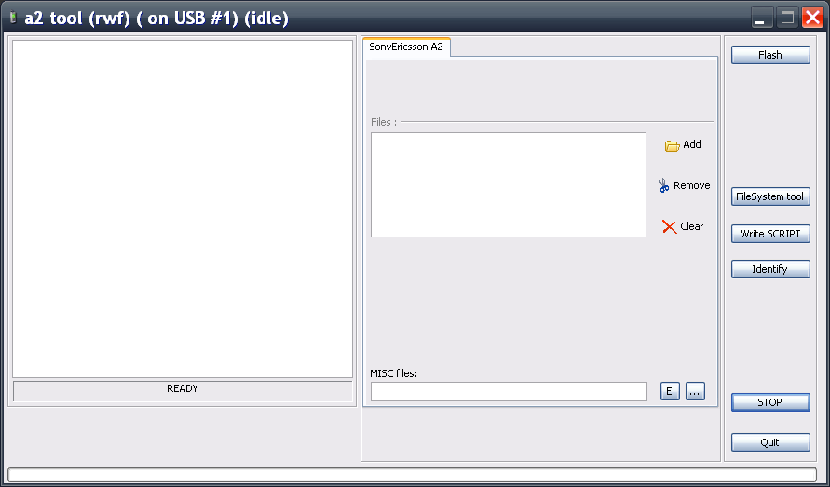
This is the main screen of A2uploader. With the identify button you can check your IMEI number, current firmware and device name.
Add the firmware:
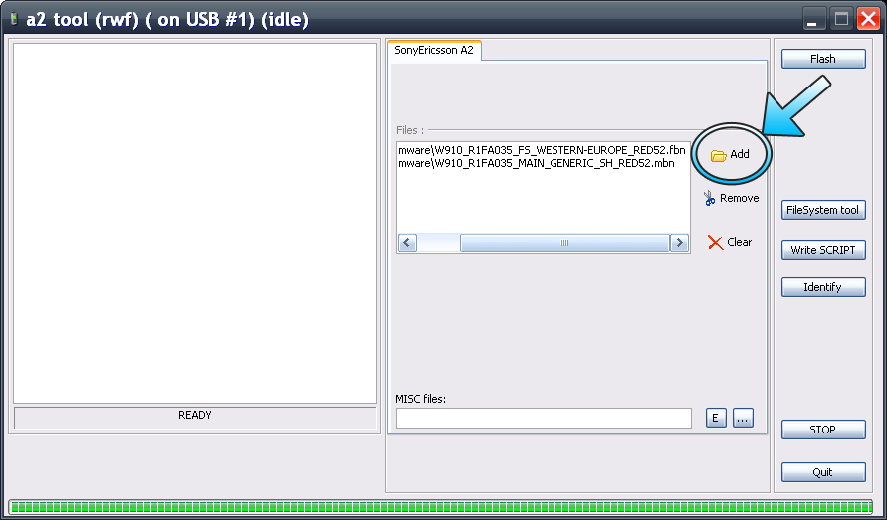
Press the button add and select the main firmware file you just downloaded, it must have a *.mbn extension. Now pres sok, you’re back on the main screen and the firmware file is added to the box.
Again press add and now select your FS file, this file must have *.fbn extension.
Press flash:
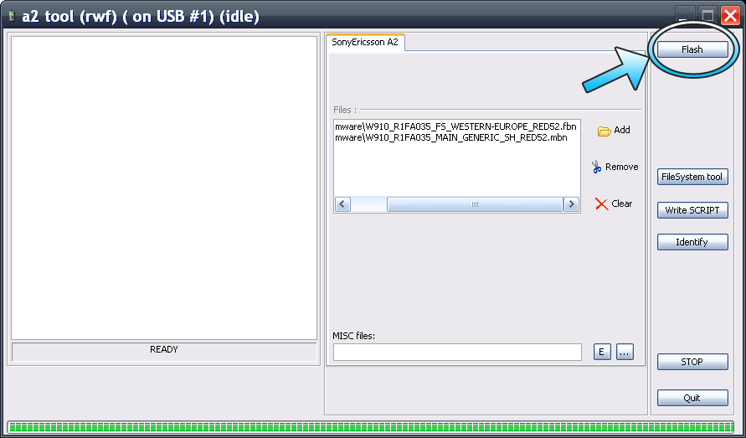
Press the flash button.
Now the program will ask you to hold C and connect your phone.
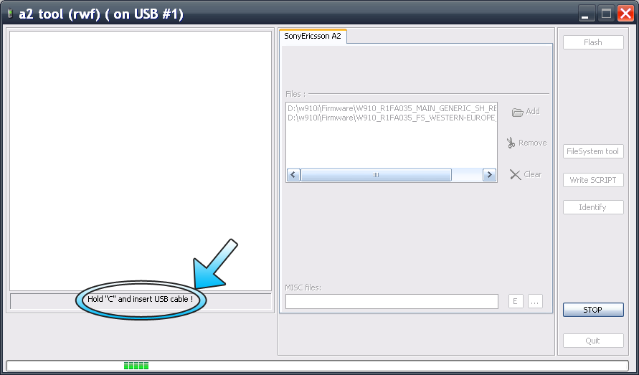
Turn off the phone, hold C (see picture below) and now insert the USB cable while holding the C button. You can release the C button when new text appears in the big box on the left.
(If holding C doesn't connect the phone connect while holding the 2 and 5 key, this applies for W760)
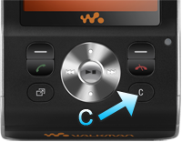
Woo! We’re almost done!
A2uploader will now flash the firmware. During this process do NOT disconnect your phone.
The green bar at the bottom will show the progress of the flashing operation.
Flashing my phone took ~400 seconds. Flashing newer A2 phones will take a bit longer as the firmware files are larger.
A2 uploader will say “ready” at the bottom when the flashing process is done, now you can safely disconnect your phone from the USB cable.
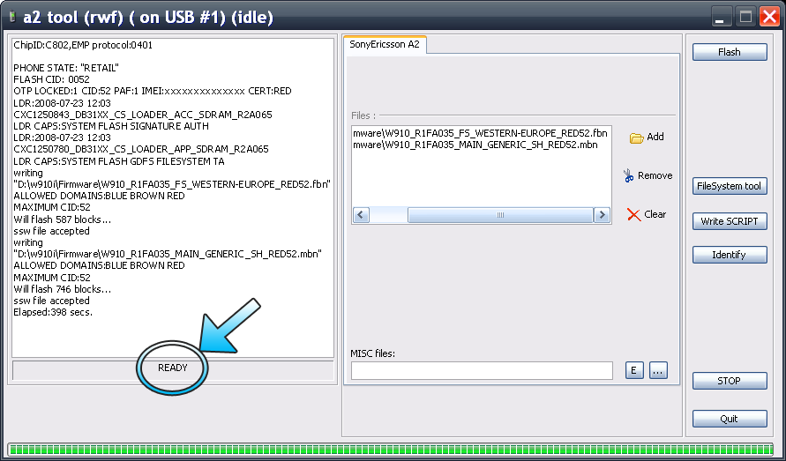
Congratulations! We’re done… oh nos! We have to add the custom files to make the phone work!
You can get the custompack from here:
http://www.esnips.co...b/A2Customfiles
or from most of the sites where you just got your firmware files from. Again the custompack needs to suit the region you chose for your FS.
What to do with the custompack:
Remove the two firmware files that are in the box and add the custompack you just downloaded (still ZIPPED!!!) to misc files with the “…” button.
Now press flash and connect the phone again holding C, like we did before. Then wait till A2 uploader says “Ready’ again and disconnect.
You can allso manually add the custom pack, unzip it the zip file, press filesystem tool on A2 uploader, connect your phone while holding C (check back for an in depth description) and then navigate to tpa/preset/custom and drop all files from the zip file there.
That was not so hard was it? Congratulations for making it all the way down here and happy modding!
© Photographer, March 2009
Respect: the_laser for A2 uploader.

